BIGTREETECH
E3 RRF V1.1
User Manual

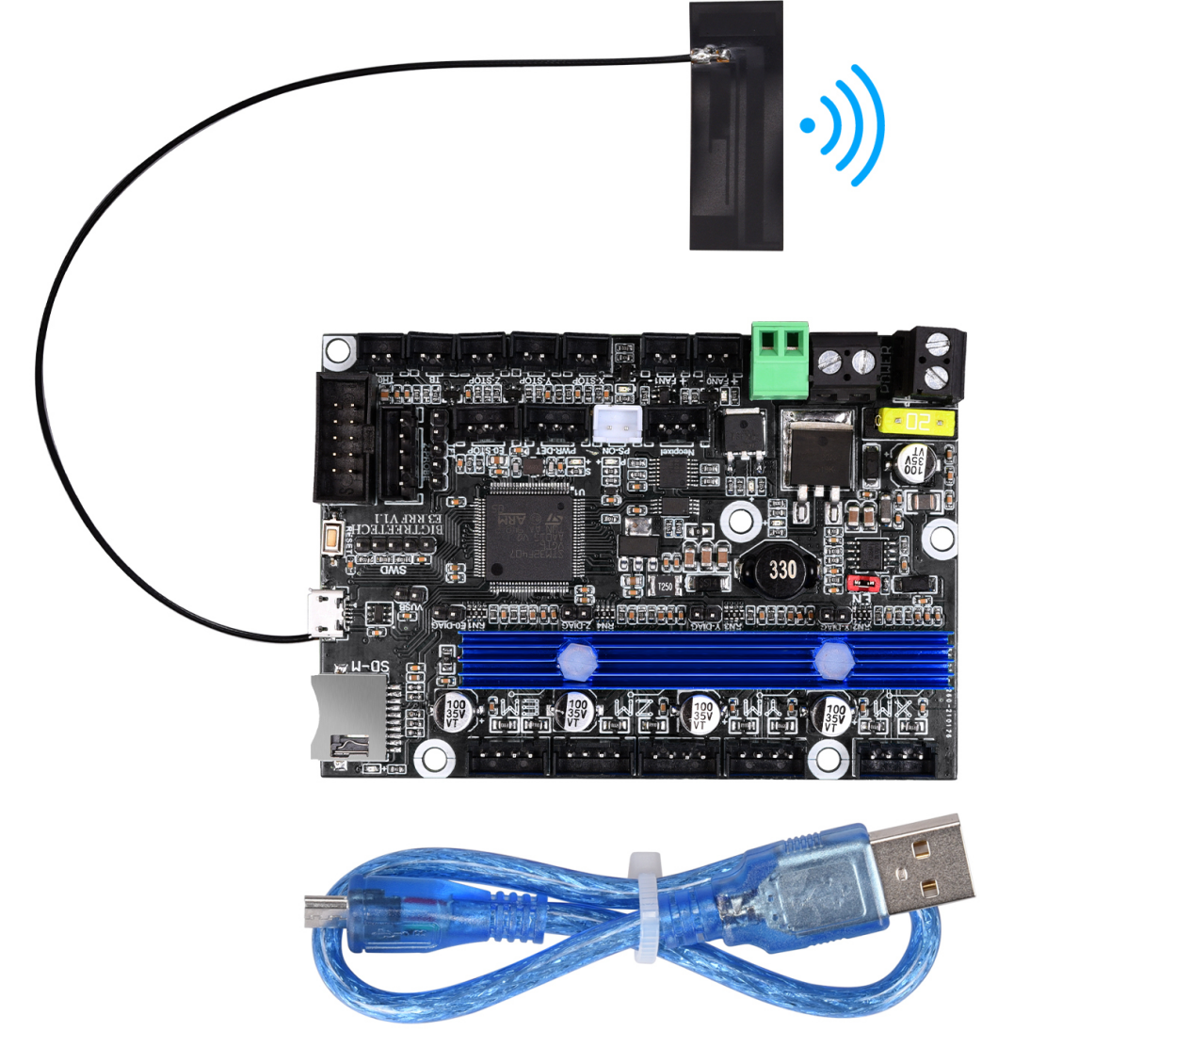

I. Introduction
- E3 RRF V1.1 motherboard is launched by the 3D printing team of Shenzhen BIGTREE Technology Co., Ltd. tailored for Ender3 series printers specially, which perfectly replaces the original Ender3 series printer motherboards.
- Motherboard Features:
1）The main control chip uses STM32F407VGT6, ARM-level 32-bit Cortex-M4 processor, and the main frequency is up to 168MHz 1Mbytes Flash 192Kbytes SRAM + 4Kbytes backup SRAM;
- Using AO1284 power chip, support DC12/24V power input, the maximum output current can reach 4A, input and output have filter circuit, which greatly reduces power ripple and radiation interference;
- The heating bed MOS tube uses WSK220N04, which has low on-resistance, larger heat dissipation area and reduced heat generation;
- Add protection circuit: The on-board power supply anti-reverse design and plug-in fuse can effectively protect the motherboard from being burned; the thermistor interface is equipped with a protection circuit, even if 24V leakage occurs, the chip pins will not be burned;
- Onboard Sensorless homing function, plug in the jumper to use this function;
- Reserve functional interfaces such as automatic leveling, RGB light, continuous printing after power failure, shutdown after printing, and material interruption detection;
- Onboard EEPROM: AT24C32;
- Parallel type dual Z-axis interface;
- One-piece heat sink, the heat dissipation area is increased, and the heat dissipation capacity is enhanced;
- Two CNC fan interfaces;
- Compatible with all export touch screens of BTT and the original LCD12864 screen of Ender3;
- Compatible with Marlin and RepRapFirmware;
- ESP8266 module is integrated on the board, you can use ESP3D with Marlin, or DWC with RepRapFirmware;
- Marlin+ESP3D firmware or DWC+RepRapFirmware can be directly updated through the onboard MicroSD card;
- Use a non-self-elastic SD card slot to avoid the problem that the SD card cannot be used due to spring damage;
- Using MICRO USB interface, the motherboard is compatible with more types of printers;
- DCDC5V is effectively isolated from USB5V, which can be selected by jumper caps to avoid the computer port burnout caused by short circuit. 2. Motherboard Parameters:
Appearance size: 100.75 * 70.25mm
Installation size: For details, please see E3 RRF V1.1-SIZE.pdf
Number of floors: 4 floors
MCU: ARM Cortex-M3 STM32F407VGT6
Power input: DC 12 / 24V
Logic voltage: 3.3V
Motor driver: UART mode of onboard TMC2209;
Motor driver interface: XM, YM, ZAM, ZBM, EM
Temperature sensor interface: TH0, THB, 2 channels 100K NTC (thermal resistance)
Display screen: all serial port touch screens of BTT, Ender3 original LCD12864 screen
PC communication interface: MICRO USB, easy to plug and unplug, communication baud rate 115200
Support file format: G code
Recommended software: Cura, Simplify3D, pronterface, Repetier-host, Makerware
II. Motherboard Indicator Light Description
After the motherboard is powered on:
The 3.3V red light is the power indicator: the red light is on, indicating that the power supply is normal;
Status red light is the status indicator: it will flash when the firmware is updated, and it will be closed after the update is completed;
D14 green light is hot bed HB status indicator: always on when heating, and off when not heating;
D12 green light is heating rod E0 status indicator: always on when heating, and off when not heating;
D15 green light is CNC fan FAN0 status indicator: it lights up when it is turned on, and goes out when it is turned off;
D16 green light is CNC fan FAN1 status indicator: it lights up when it is turned on, and goes out when it is turned off.
III. The Motherboard and PC Communication
The motherboard communicates with the PC (Windows system) through the [USB] interface. The driver needs to be installed before the communication can be used normally.
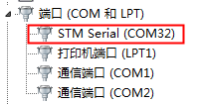
IV. Motherboard Interface Description
- Motherboard Size Chart： Please refer to the file BTT E3 RRF V1.1-SIZE.pdf

- Motherboard Wiring Diagram
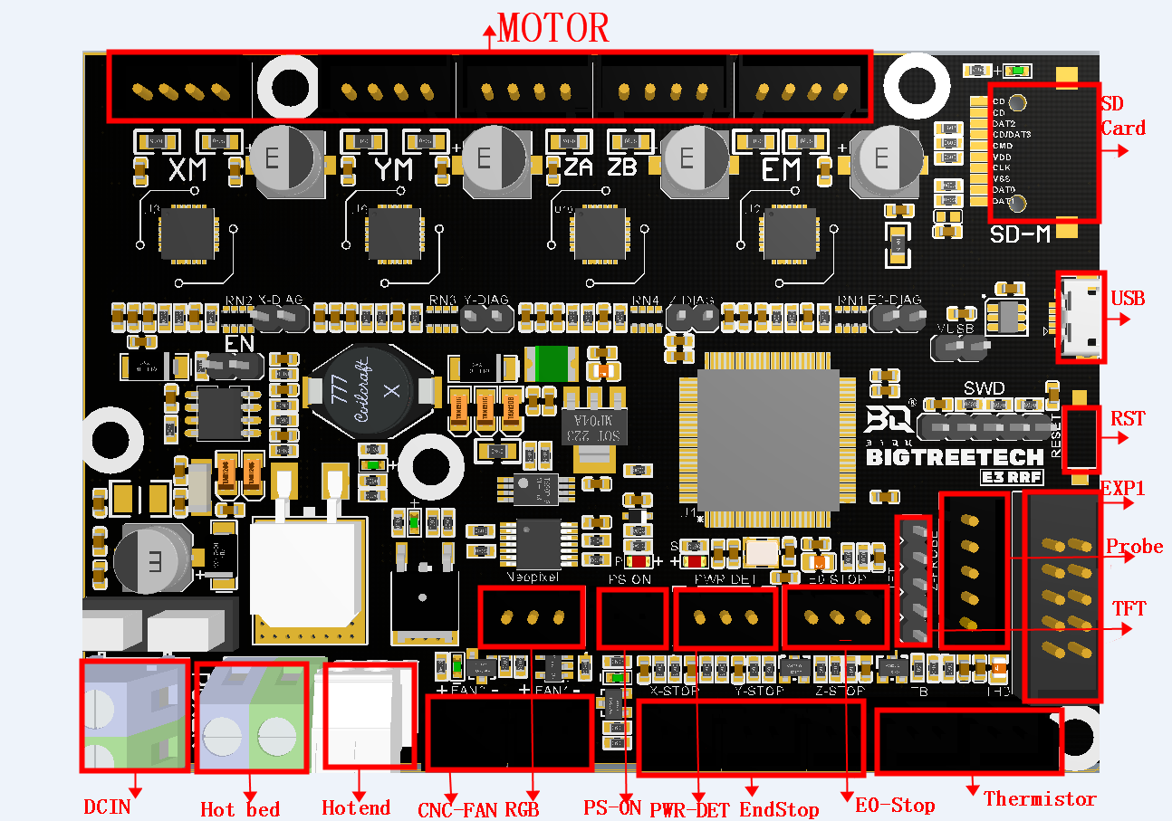
- Sensorless Homing Function Selection：
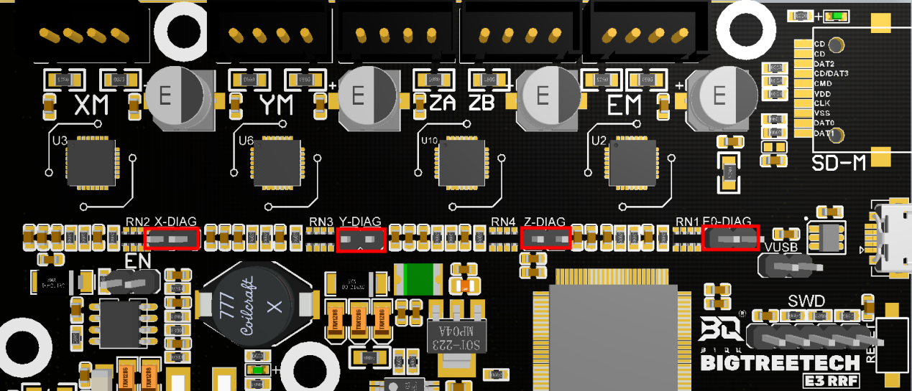
Use the jumper to connect the corresponding axis as shown in the figure to use the Sensorless homing function;
Note：If you select this function, you cannot use external ENDSTOP! ! !

- Connection with BIGTREETECH Relay V1.2：
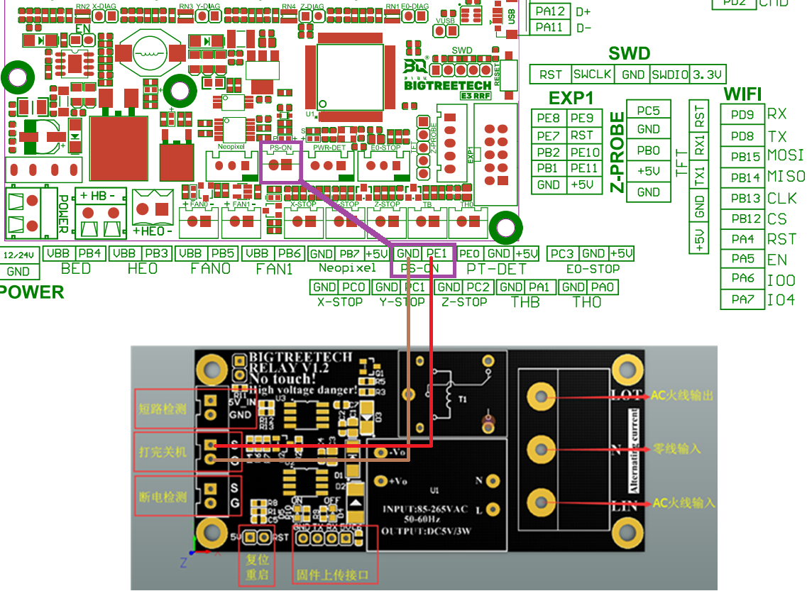
- Connection with BTT UPS 24V V1.0：
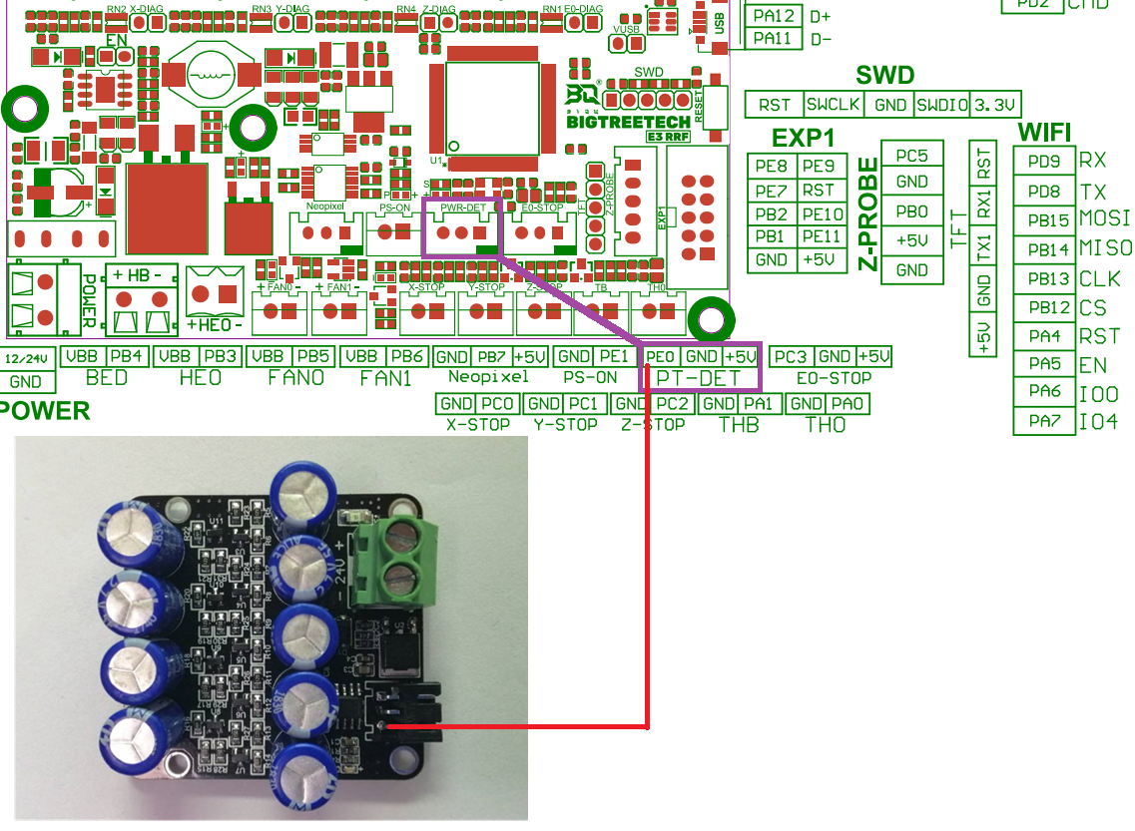
- Connection with RGB Light：
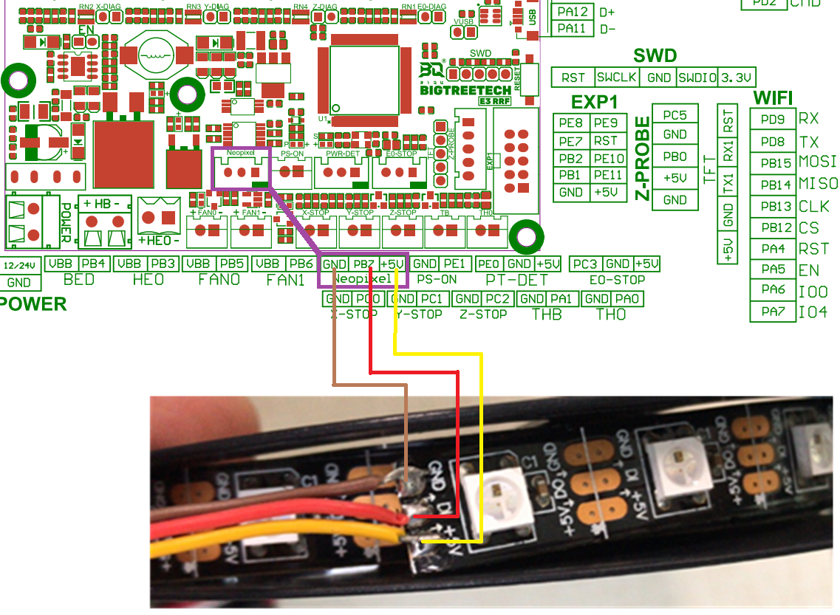
- Connection with BL touch：
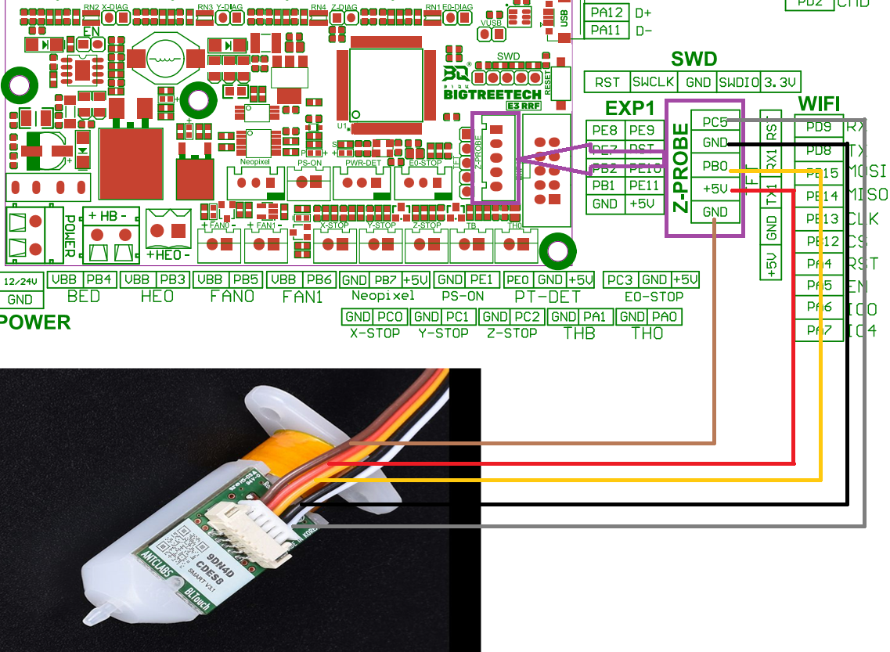
- Power Selection Instructions
1）When using DCDC5V: the jumper is inserted in the following "EN" position
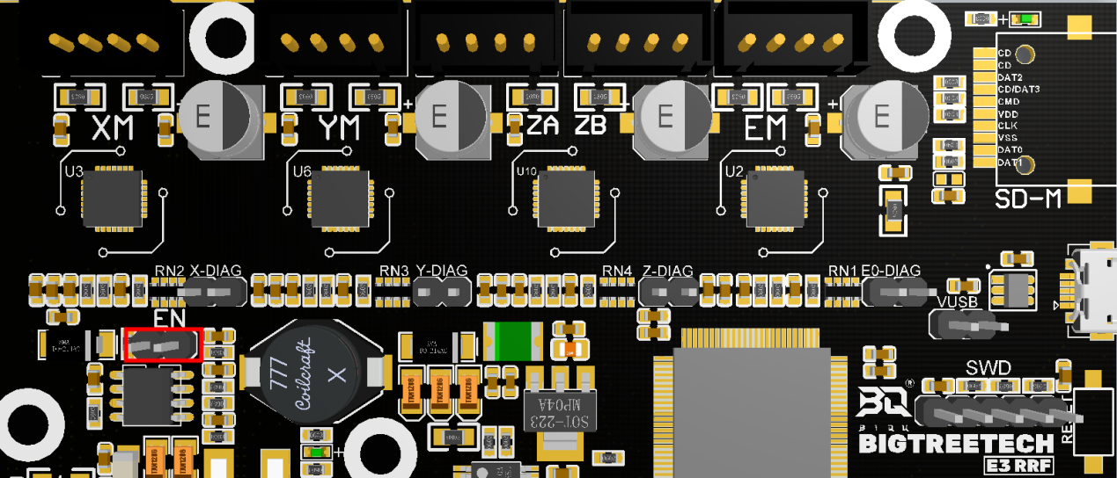
2）When using USB to power the motherboard: the jumper is inserted in the following "VUSB" position
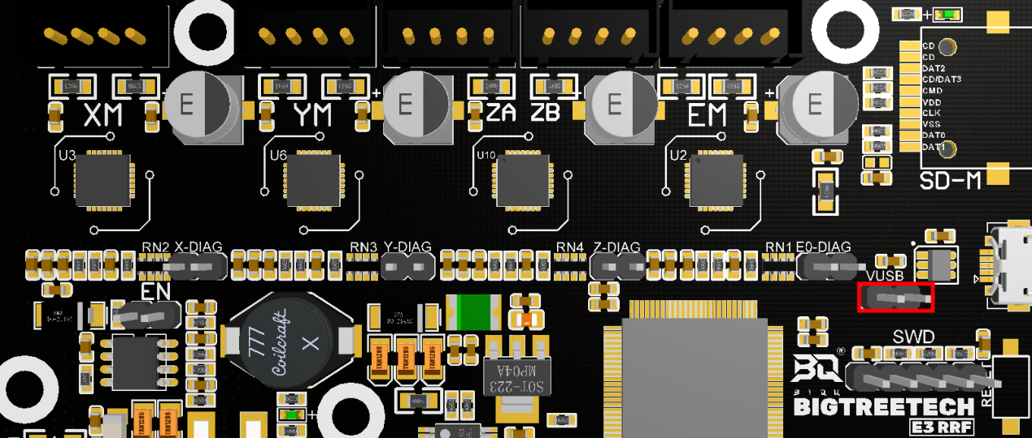
10. The line difference between RRF E3 V1.0 and E3 RRF V1.1:
The first pin of the RRF E3 V1.0-FPC socket is GND
The first pin of E3 RRF V1.1-FPC socket is 3.3V
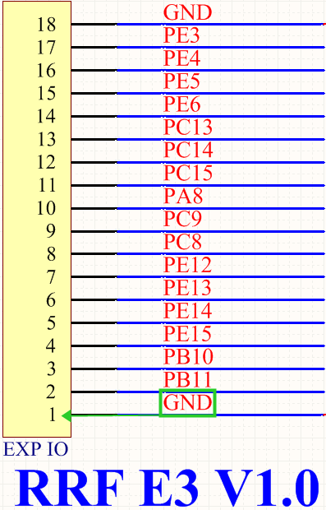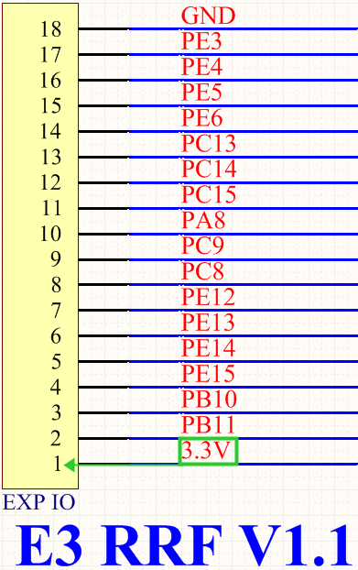
V. The Firmware Description of E3 RRF V1.1
The firmware used for testing (Ender3 series) will be installed in the factory motherboard, which can be used directly or change according to your own needs.
- How to get motherboard firmware
Ask customer service or technical personnel to obtain;
Log in to our original website to download: https://github.com/bigtreetech
- Motherboard firmware update method
Select the firmware.bin file in the compiled firmware package and copy it to the root directory of the SD card
Note: The file name cannot be changed, firmware.bin must be lowercase!
Insert the SD card into the SD card slot of the motherboard, re-power on or press the reset button, wait for about 10 seconds to complete the update;
- For motherboard firmware DIY, please refer to E3 RRF V1.1-PIN.pdf.
- For RRF firmware and parameter configuration tutorial, please refer to: E3 RRF User Manual.pdf

VI. Notes
- The name of the firmware file in the SD card cannot be changed (including upper and lower case);
- The wiring process must be carried out under the premise of power failure, and power can be turned on after checking that the wiring is correctly connected and the driver is correctly inserted. This prevents the motherboard and driver from being burned due to wrong wiring, causing unnecessary losses;
- The LCD screen only supports the LCD12864 screen with this interface CR10_STOCKDISPLAY;

If you still encounter other problems during using, you are welcome to contact us and we will take care of your answer; if you have any good comments or suggestions on our products, you are also welcome to give us feedback, and we will carefully consider your comments or suggestions, thank you for choosing BIGTREETECH products,thank you!

